**Homework 7**

Deliverables [75 pts]

For this week, please provide screen captures in an MS Word document or PDF that show:

**VAGRANT**

5 pts The output from the vagrant box list command after you execute the

vagrant box add command.

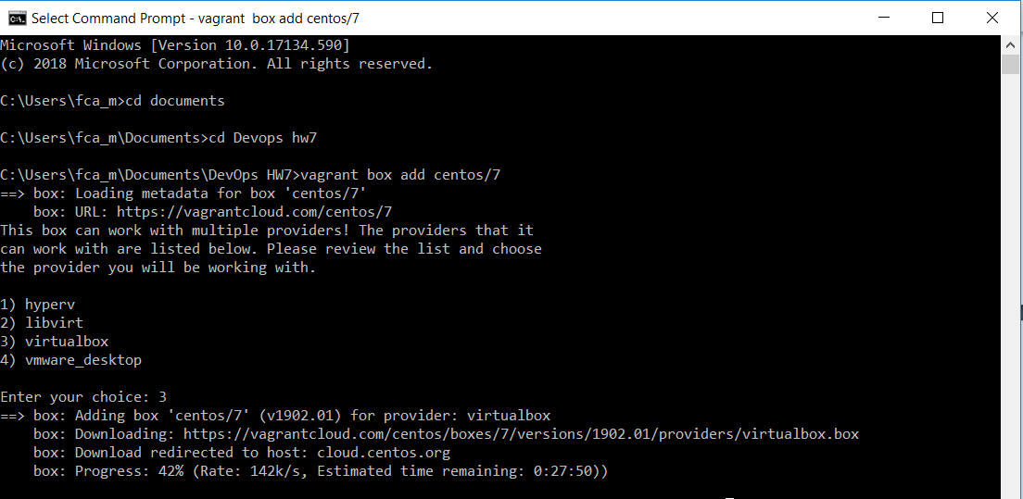

5 pts The output from the vagrant status command when your VM is not running.

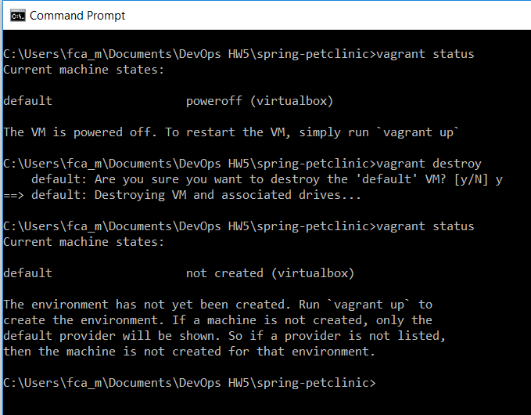

5 pts Your browser accessing the main page of the website from the Vagrant server while

the VM is not running at <http://localhost:8484>.

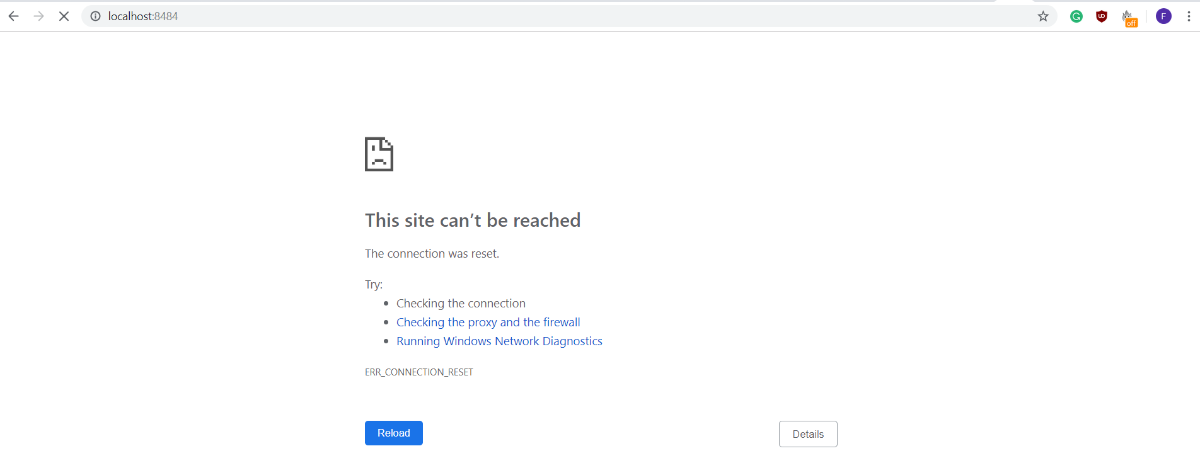

5 pts The output from the vagrant status command when your VM is running.

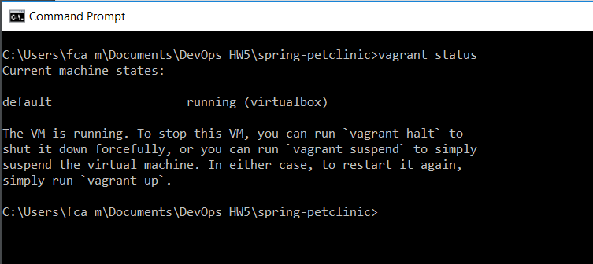

5 pts Your browser accessing the main page of the website from the Vagrant server when

your VM is running at <http://localhost:8484>.

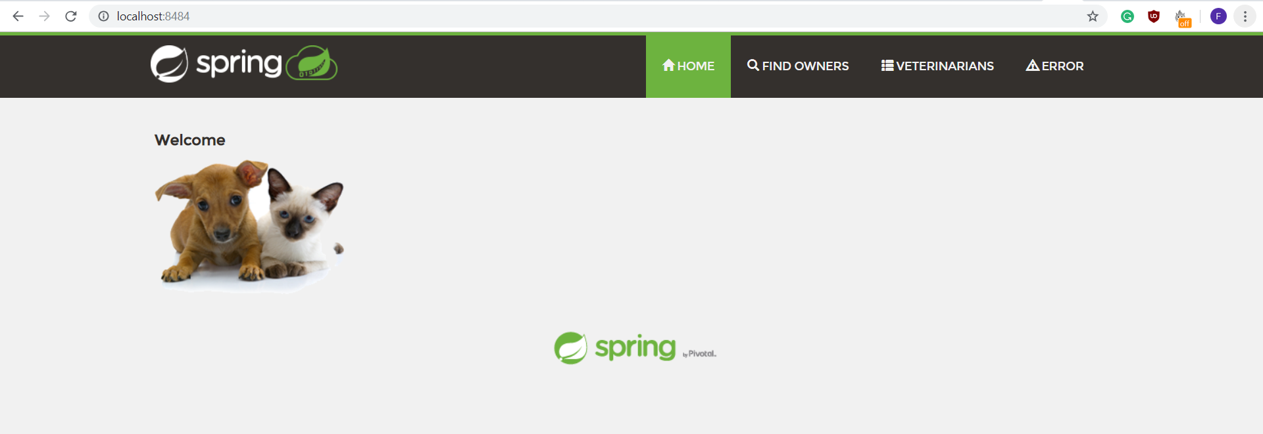

**HEROKU**

5 pts Your Heroku application list showing the Spring PetClinic application.

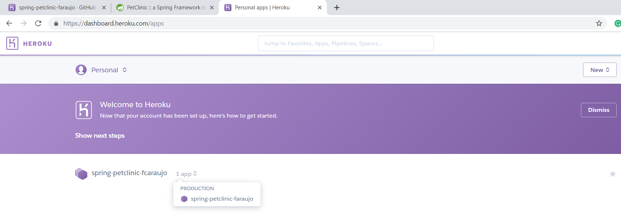

5 pts Your Heroku Spring PetClinic pipeline.

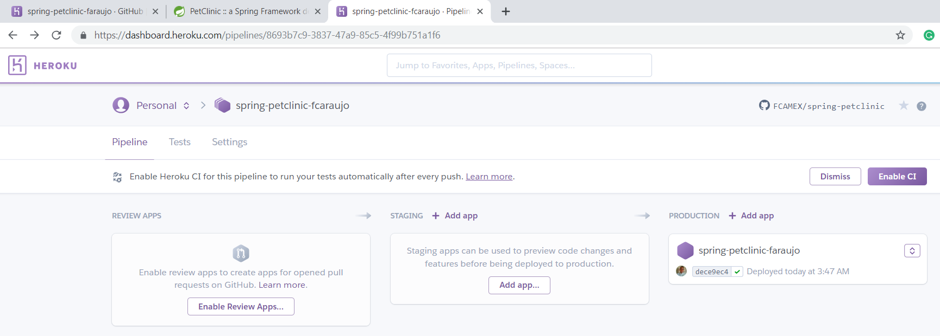

5 pts Your browser accessing the main page of the Spring PetClinic from Heroku.  
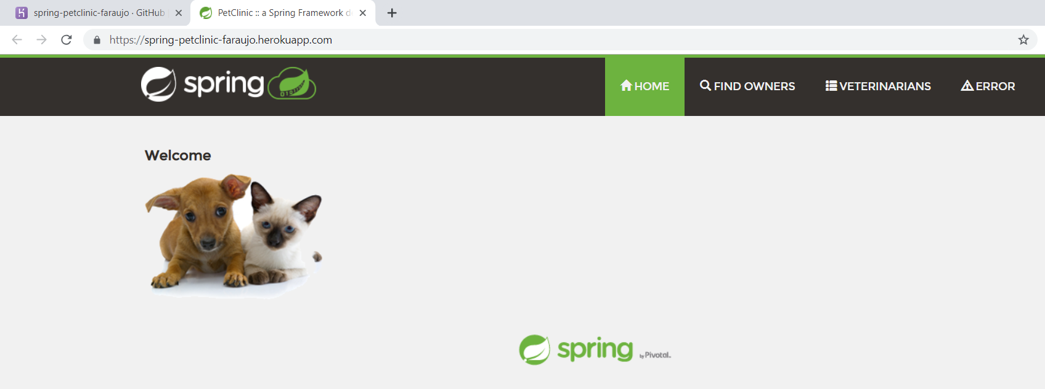

**CHEF**

5 pts The output of the generate cookbook command.

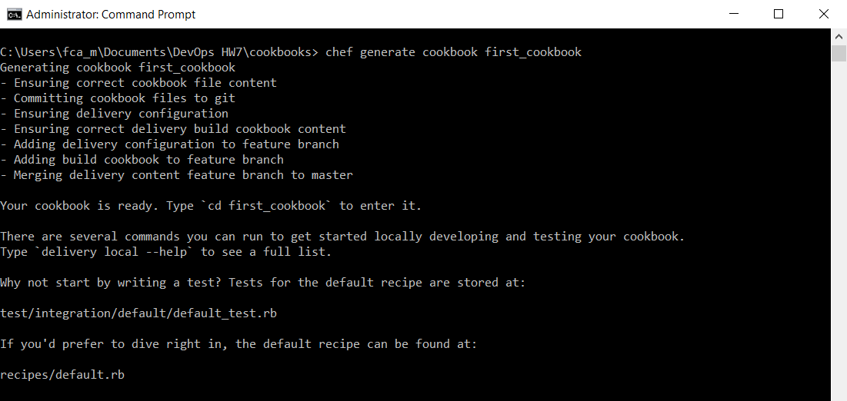

5 pts The directory structure for your cookbook.

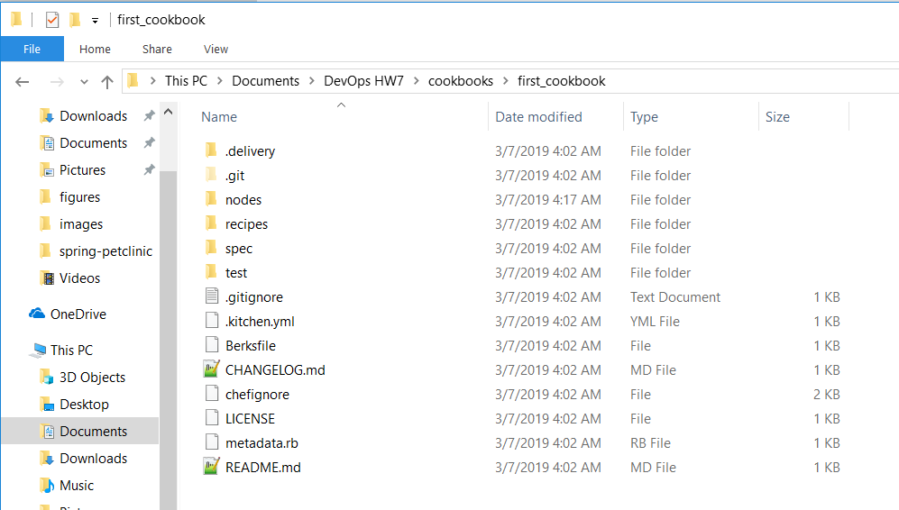5 pts The content of the first_cookbook.rb recipe.

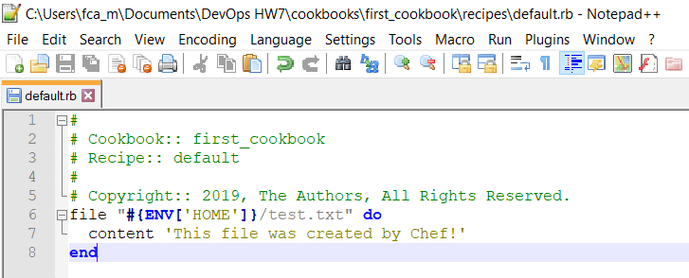

5 pts The successful execution of the first_cookbook.rb recipe the first time. Show the

directory where the test.txt file will be created and the contents of that file after

running the chef recipe.

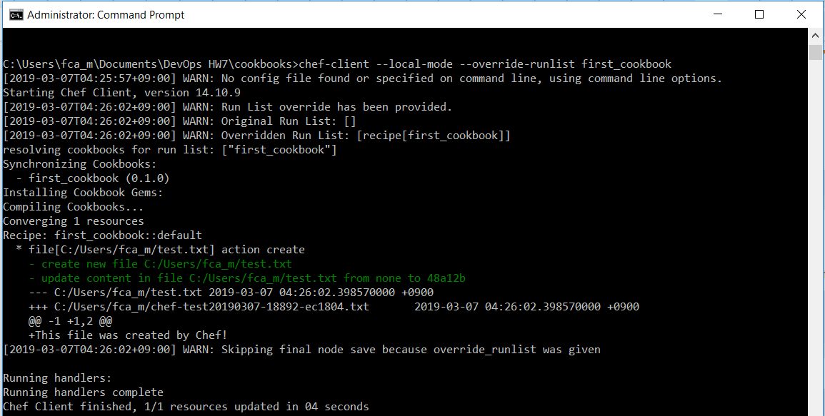

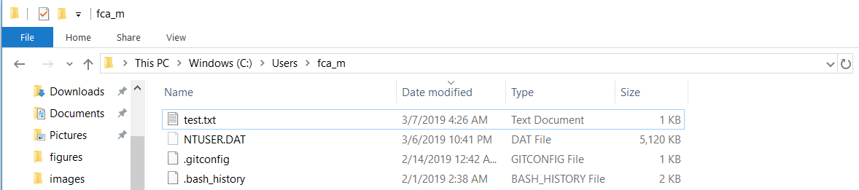

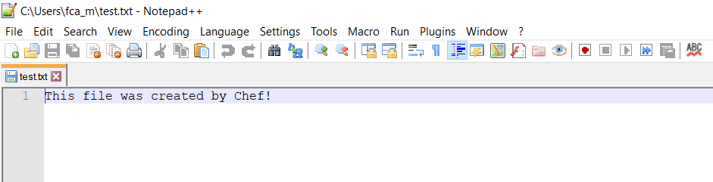

5 pts The successful execution of the first_cookbook.rb recipe after deleting the file.

Show the directory that used to contain the test.txt file and the contents of that

file after running the chef recipe.

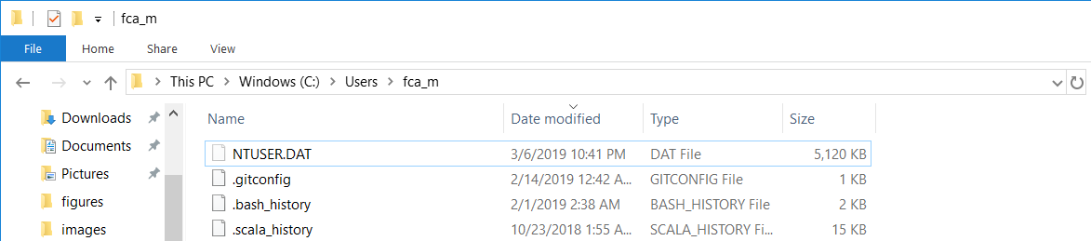

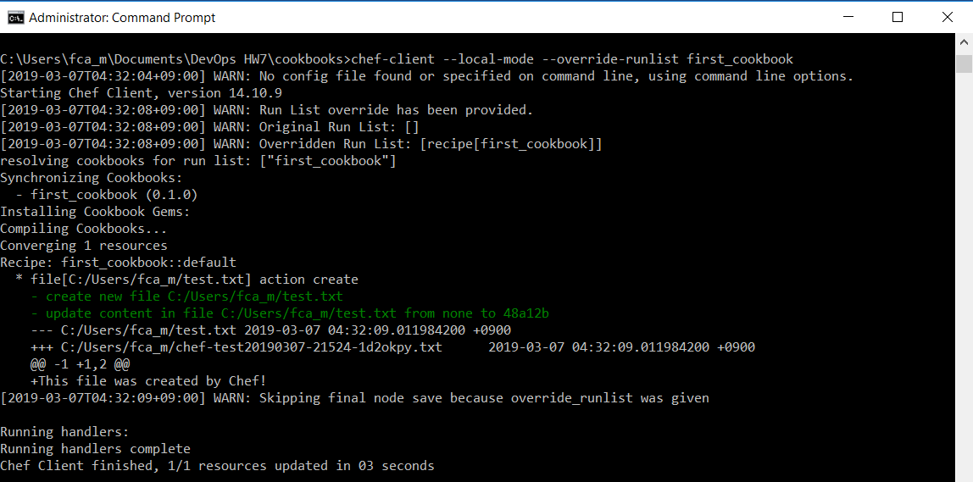

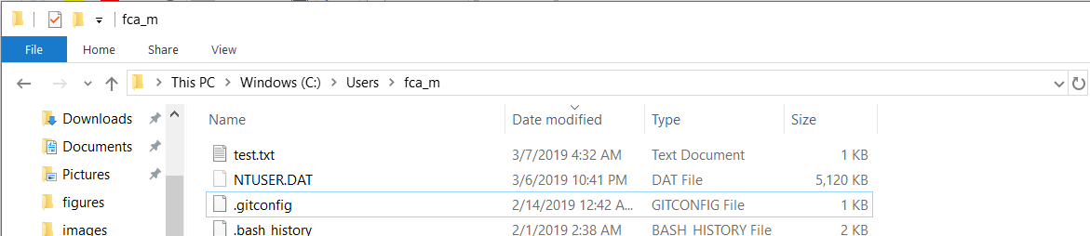

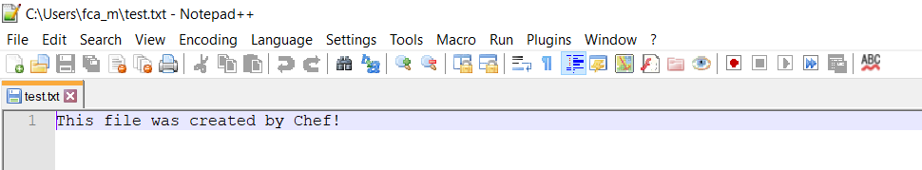

5 pts The successful execution of the first_cookbook.rb recipe after changing the contents

of the test.txt file. Show the contents of test.txt file after your change and the

contents of that file after running the chef recipe.

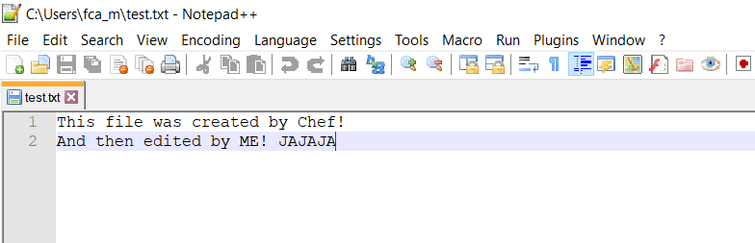

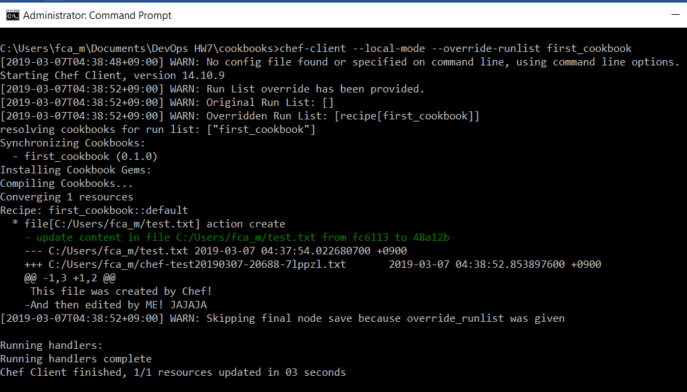

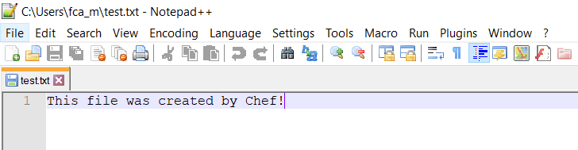

5 pts The successful execution of the first_cookbook.rb recipe after changing the contents

of the recipe itself. Show the contents of first_cookbook.rb file after your change

and the contents of test.txt after running the chef recipe.

